**DATABASE Design**

**How does Uber work?**

It takes only five steps to finish the ride, but these steps made a revolutionary change on the market of taxi services. The app flow includes the following 5 steps:

1. **Request.**
2. **Matching.**
3. **Ride.**
4. **Payment.**
5. **Rating.**

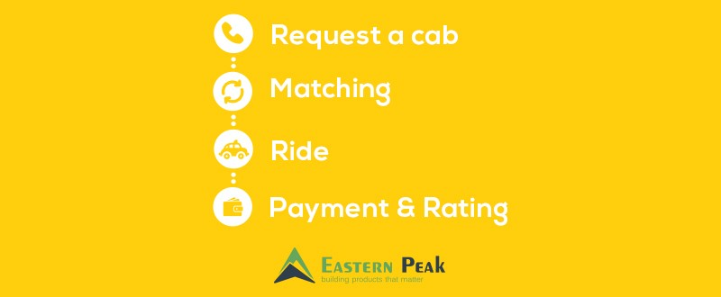

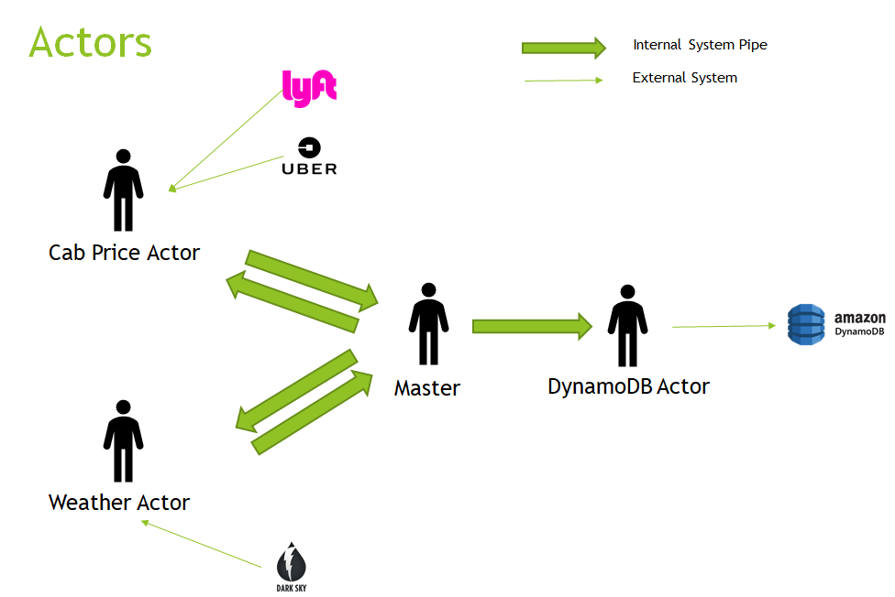

**Architecture diagram**

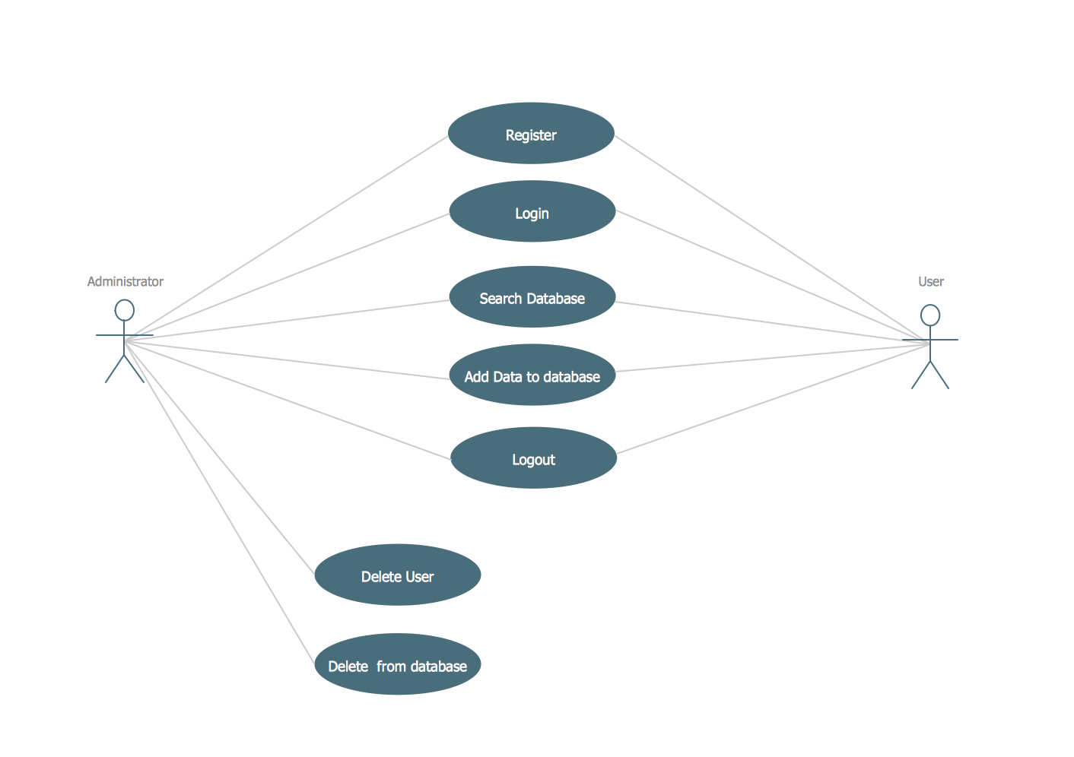

**UML Diagram**

**1.Class Diagram**

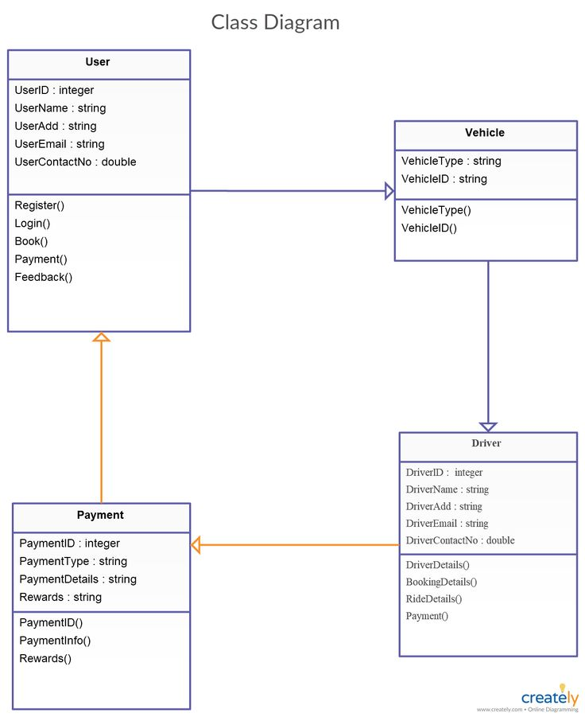

**2. Use case diagram**

